Students Handout

MVC(Model View Controller)Exercise1

**Overview:**

In this exercise, you will create a simple Job Portal with three controllers: JobSeekerController, and Public Controller. The application allows job seekers to register, log in, view and update their profiles, view a list of jobs, view full job details, apply for jobs.

**Technologies:**

ASP.NET Core MVC

C#

Repository Pattern

Dependency Injection

Exercise Steps:

Create Public Controller with Following Actoion

1.Registration

2.Login

Create JobSeeker Controller

1.Profile

2.Post Action For Profile update

3.ListAllJobs

4.ApplyJob

5.My Applications

**Repository Pattern:**

Implement a generic repository pattern for handling data access.

Create repositories for User, and Job,Application

Register services in IOC Container

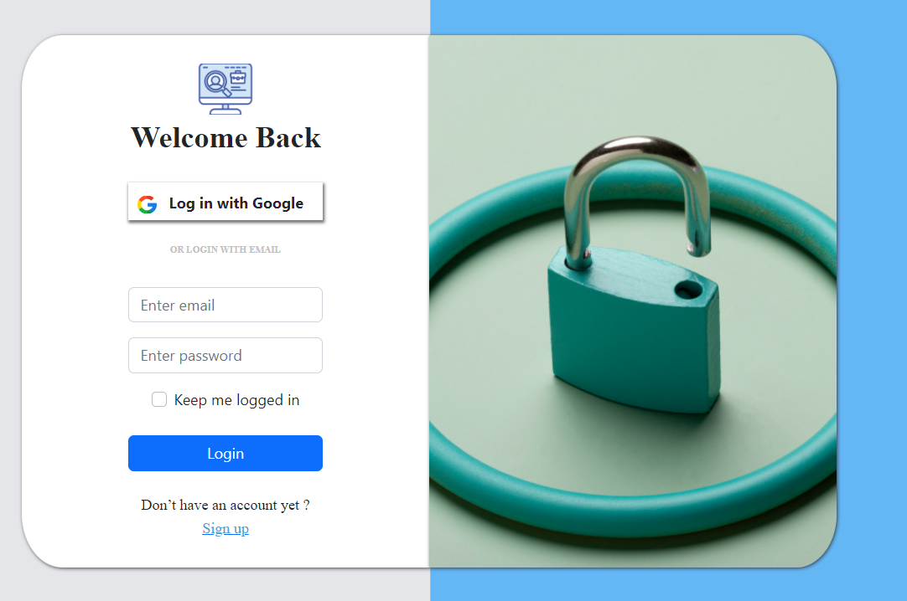

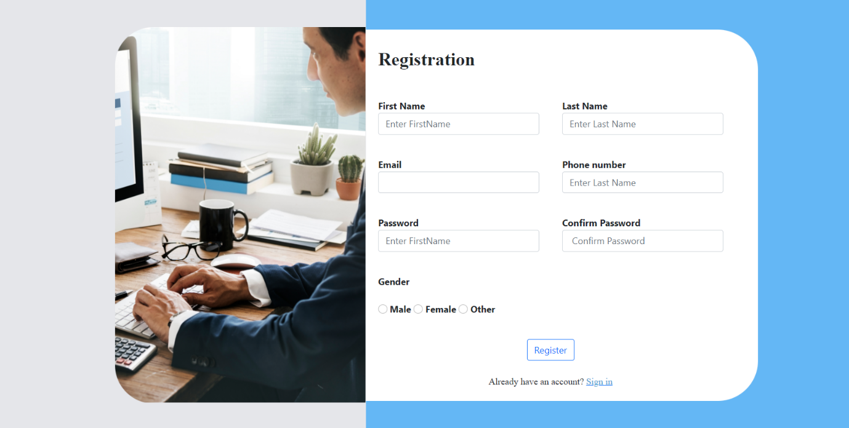

Create A JobseekerController There is actions for View anfd update ptofile of logged User.,List all jobs,apply Jobs and list all Applications…

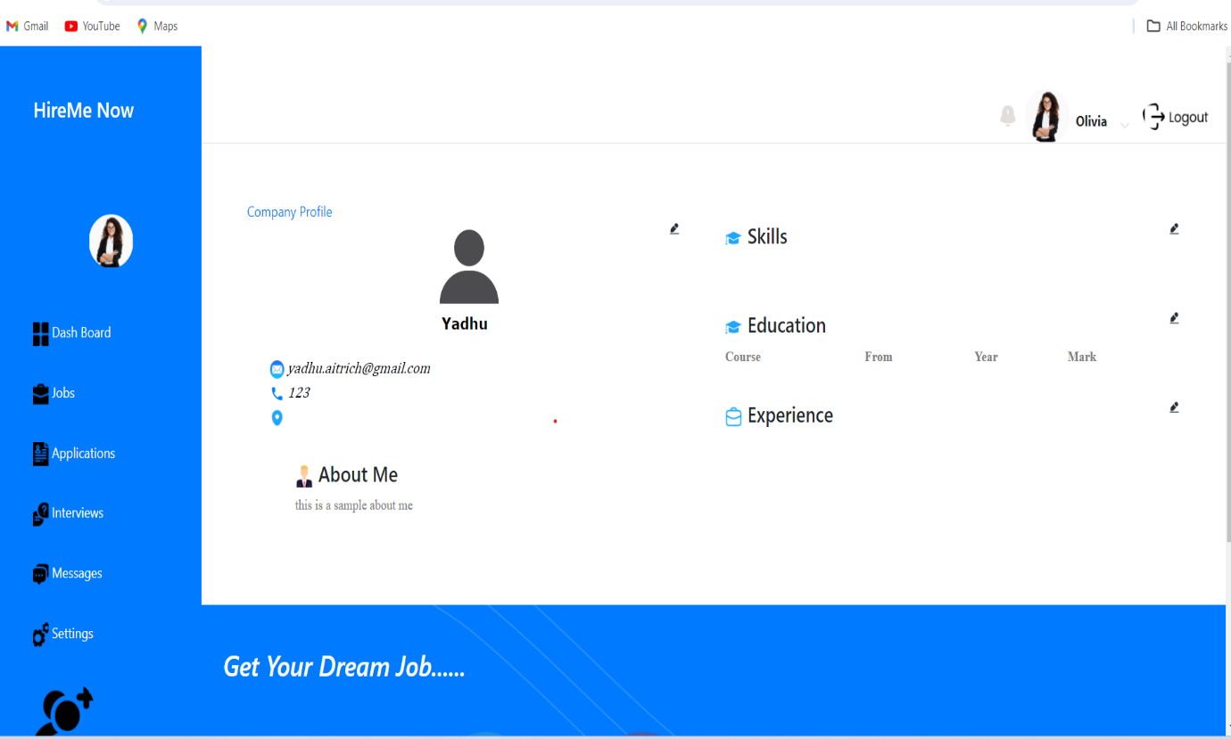

Jobs List

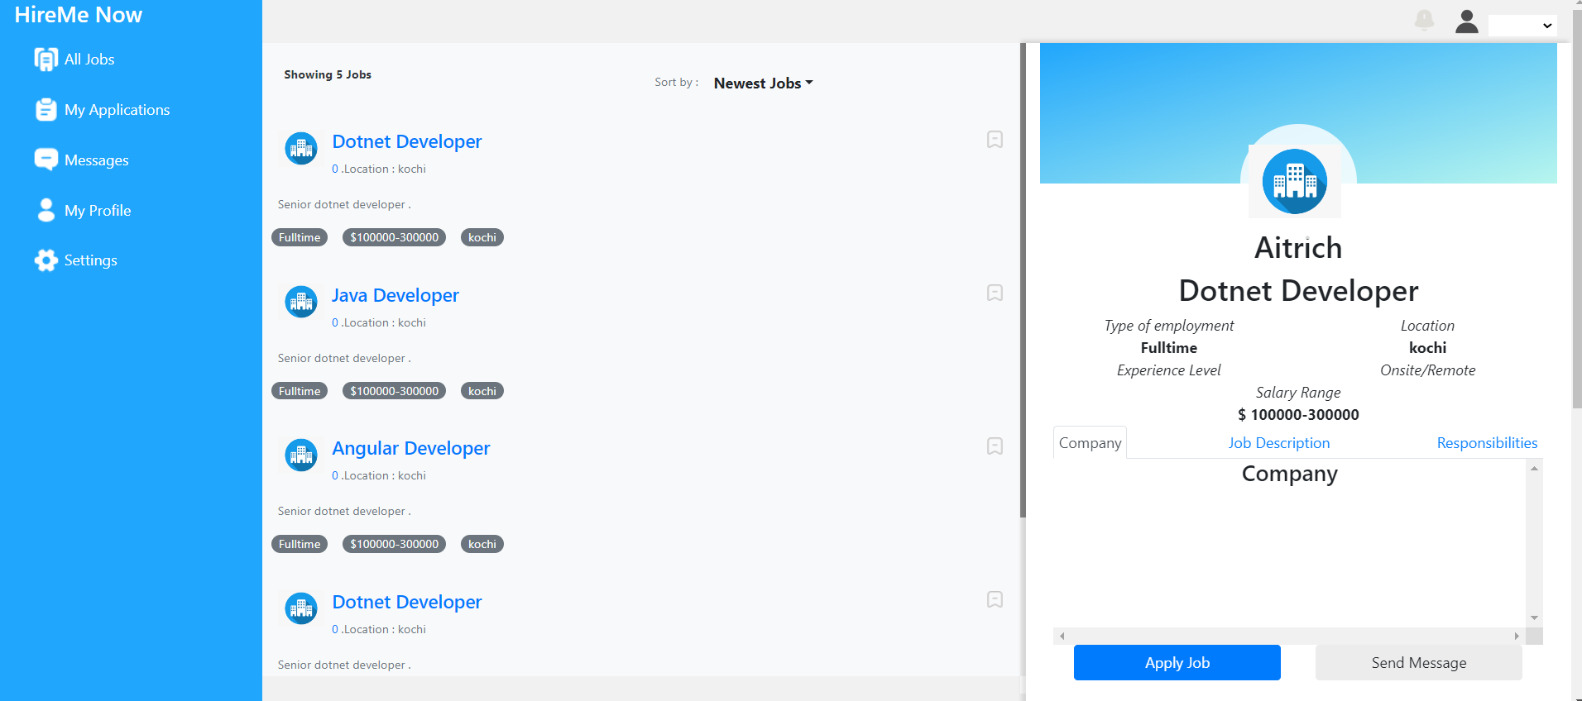

MyApplications Applications